【Product Picture】

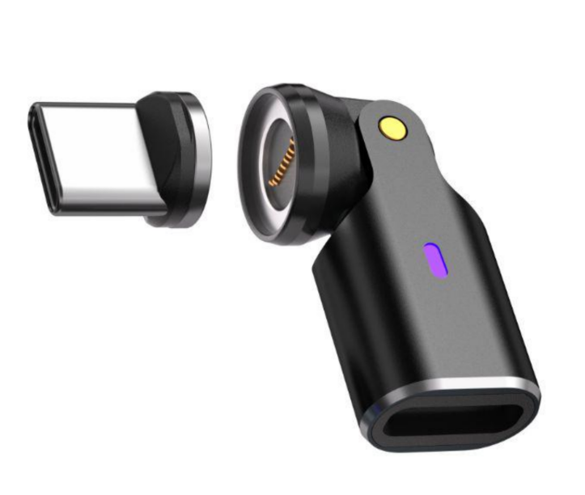
【Product Description】
The CA446D USB-C to USB-C L-Type Adapter is a compact and versatile connectivity solution designed for high-power charging and flexible device positioning. Featuring a dual-axis rotating connector with a 360° rotating interface and 180° elbow design, combined with a magnetic USB-C interface, it enhances usability, cable management, and connection stability while supporting up to 240W power delivery and reliable data transmission.

【Tech Specs】
Technical Specification | Description
Model | CA446D
Product Type | USB-C to USB-C L-Type Adapter
Color | Black
Connector Type | USB-C Female to USB-C Male
Interface Design | 360° Rotating Interface + 180° Rotating Elbow+ Magnetic USB-C Connector
Data Transfer Rate | Up to 480Mbps
Power Delivery | PD3.1 Up to 240W (48V/5A Max)
Function Support | Charging, Data Transfer, OTG
Connector Material | Nickel-plated
Material | Aluminum Alloy Shell
Net Weight | 4g

【Features】
- Dual-Axis Rotation Design: Equipped with 360° rotation and 180° elbow adjustment, allowing flexible positioning and reducing cable strain.
- Magnetic Connection: Magnetic USB-C interface enables quick attachment and detachment while improving connection convenience.
- High Power Delivery: Supports up to 240W PD charging, ideal for laptops, tablets, and high-power USB-C devices.
- Compact and Lightweight: Ultra-light 4g design enhances portability without compromising durability.
【Application Environment】
- Laptop Charging Setup: Perfect for optimizing cable direction when charging USB-C laptops in tight or confined spaces.
- Mobile Device Usage: Enhances ergonomics for smartphones and tablets during charging or data syncing.
- Gaming and Entertainment: Reduces cable interference when holding devices during gaming or media consumption.
- Workstation Organization: Improves cable management and minimizes connector wear in desktop setups.
【Important Notice】
- Magnetic Alignment: Ensure proper alignment of the magnetic connector to maintain stable electrical contact.
- Compatibility Check: Confirm device and cable support USB-C PD 240W for optimal charging performance.
- Data Limitation: This adapter supports USB 2.0 data speeds and does not support video output.
- Handling Precaution: Avoid strong impacts or forced rotation to prevent damage to internal rotating and magnetic structures.

